# **EfficientNet**

* When CNN models are developed , they are done at the fixed cost.
* They are scaled up later to achieve better accuracies when more resources are available.
* For example, the ResNet 18 model can get scaled up to the ResNet 200 model by adding more layers.
* Most of the time it helps us to improve the accuracy of models on most of the renowned datasets, but the conventional techniques of model scaling are very random.

EfficientNet uses a technique called **compound coefficient** to scale up models in a simple but effective manner. Instead of randomly scaling up width, depth or resolution, compound scaling uniformly scales each dimension with a certain fixed set of scaling coefficients.

# Compound Model Scaling

The compound scaling method is based on the idea of balancing dimensions of width, depth, and resolution by scaling with a constant ratio. The equations below show how it is achieved mathematically,

Depth d = ά^θ

Width w = β^θ

Resolution r = γ^θ

Equation

ά*β^2*γ^2 ~ 2

Where ά, β, γ >= 1

For EfficientNet B0 ά = 1.2, β = 1.1, γ = 1.15

These values are defined by grid search algorithm

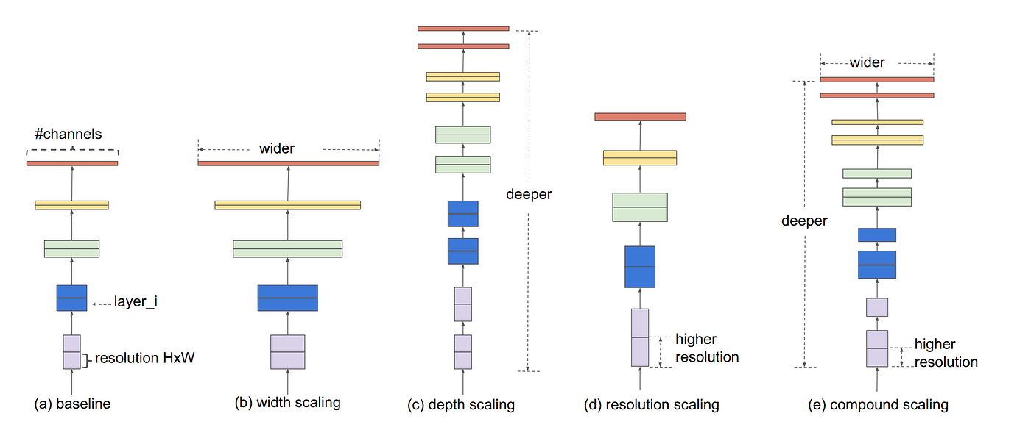



 



Key Note: Compound Scaling also improves the accuracy of previous CNN models such as **MobileNet** and **ResNet** by 1.4% and 0.7% respectively.

Points

CNN models scale up for better accuracy with more resources.

Conventional scaling is random

EfficientNet uses systematic compound scaling.

Compound scaling balances width, depth, and resolution with fixed coefficients.

EfficientNet B0's coefficients (1.2, 1.1, 1.15) are chosen by grid search.

Systematic scaling in EfficientNet outperforms random scaling approaches.

# Grid Search

Grid Search technique is used to tune the parameters ά, β and γ according to the condition. It creates a 3x3x3 grid which will check out all the values of ά, β, γ until the most efficient value is found.

**EfficientNet B1**

EfficientNet B1 is a convolutional neural network architecture that belongs to the EfficientNet family, introduced in 2019. EfficientNet B1 is the smallest variant in the EfficientNet family.

**Key Concepts:-**

**Compound Scaling:**

**Explanation:** Compound scaling involves using a single coefficient (ϕ) to uniformly scale the depth, width, and resolution of the neural network.

**EfficientNet B1 Usage:** In EfficientNet B1, ϕ is set to 1.0, and α=1.2 for depth and β=1.1 for width. This ensures a balanced and efficient scaling of the model.

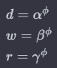

* α is the base scaling factor for depth.
* β is the base scaling factor for width.
* γ is the base scaling factor for resolution.

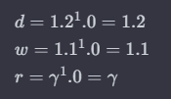

**Depthwise Separable Convolutions:**

**Explanation:** Depthwise separable convolutions involve convolving each input channel separately, followed by a pointwise convolution. This reduces parameters and computations.

**EfficientNet B1 Usage:** B1 employs depthwise separable convolutions to maintain efficiency while capturing complex features.

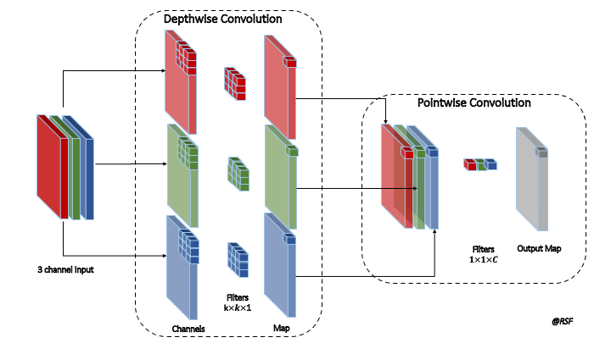

**Inverted Residual Blocks:**

**Explanation:** Inverted residual blocks expand the input, process it through depth-wise separable convolutions, and then project it back to the original dimensions.

**EfficientNet B1 Usage:** B1 incorporates inverted residual blocks to enhance feature representation within the network.

**Feature Pyramid Network (FPN):**

**Explanation:** FPN combines features from multiple levels of the network hierarchy, creating a pyramid structure to handle objects at different scales.

**EfficientNet B1 Usage:** B1 integrates FPN to improve object detection capabilities and handle varied object sizes.

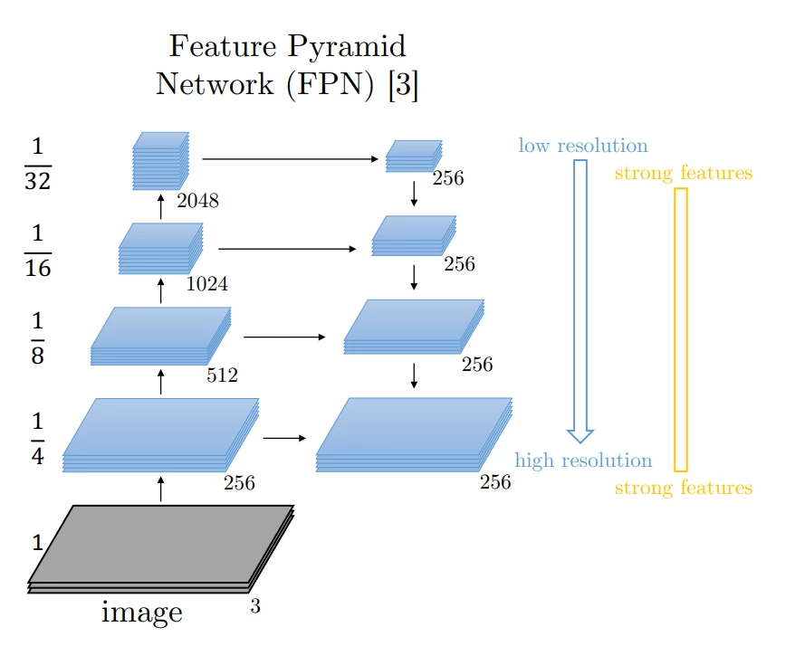

**Swish Activation Function:**

**Explanation:** Swish is a smooth, non-monotonic activation function that enhances the expressiveness of deep neural networks.

**EfficientNet B1 Usage:** B1 uses the Swish activation function for improved performance in capturing complex patterns.

**Global Average Pooling (GAP):**

**Explanation:** GAP computes the average value of each feature map, reducing spatial dimensions to a single value per channel.

**EfficientNet B1 Usage:** B1 concludes with GAP to provide a compact representation of features, aiding in classification and other tasks.